1) Delivery_time -> Predict delivery time using sorting time

> a=read.csv(file.choose())

> View(a)

> attach(a)

> summary(a)

Delivery.Time Sorting.Time

Min. : 8.00 Min. : 2.00

1st Qu.:13.50 1st Qu.: 4.00

Median :17.83 Median : 6.00

Mean :16.79 Mean : 6.19

3rd Qu.:19.75 3rd Qu.: 8.00

Max. :29.00 Max. :10.00

> plot(a$Sorting.Time,a$Delivery.Time)

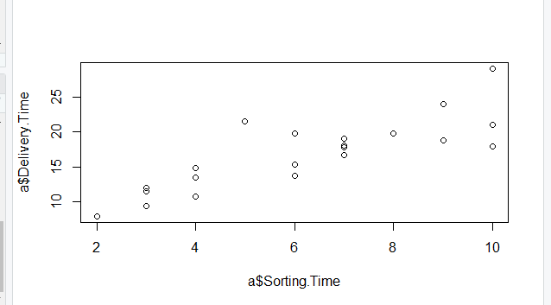

> cor(a$Sorting.Time,a$Delivery.Time)

[1] 0.8259973

> boxplot(a)

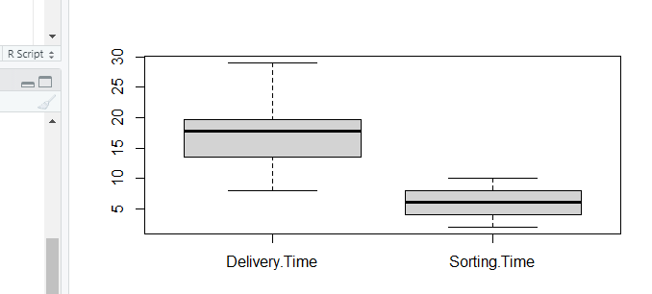

> hist(a$Sorting.Time)

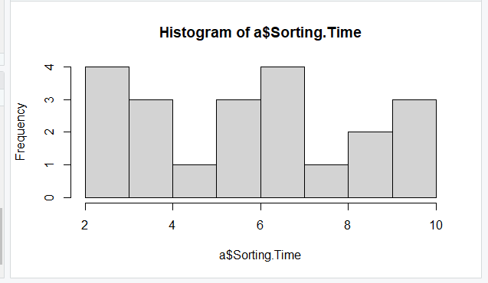

> hist(a$Delivery.Time)

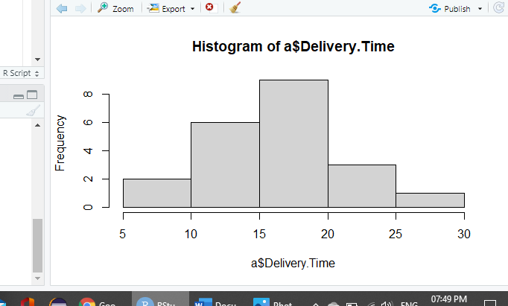

> reg <- lm(Delivery.Time~Sorting.Time)

> summary(reg)

Call:

lm(formula = Delivery.Time ~ Sorting.Time)

Residuals:

Min 1Q Median 3Q Max

-5.1729 -2.0298 -0.0298 0.8741 6.6722

Coefficients:

Estimate Std. Error

(Intercept) 6.5827 1.7217

Sorting.Time 1.6490 0.2582

t value Pr(>|t|)

(Intercept) 3.823 0.00115 **

Sorting.Time 6.387 3.98e-06 ***

---

Signif. codes:

0 ‘***’ 0.001 ‘**’ 0.01 ‘*’ 0.05

‘.’ 0.1 ‘ ’ 1

Residual standard error: 2.935 on 19 degrees of freedom

Multiple R-squared: 0.6823, Adjusted R-squared: 0.6655

F-statistic: 40.8 on 1 and 19 DF, p-value: 3.983e-06

> predict(reg)

1 2 3 4

23.072933 13.178814 16.476853 21.423913

5 6 7 8

23.072933 16.476853 18.125873 11.529794

9 10 11 12

23.072933 21.423913 19.774893 13.178814

13 14 15 16

18.125873 11.529794 11.529794 13.178814

17 18 19 20

16.476853 18.125873 9.880774 18.125873

21

14.827833

> reg$residuals

1 2 3

-2.07293294 0.32118644 3.27314665

4 5 6

2.57608696 5.92706706 -1.12685335

7 8 9

0.87412675 -2.02979366 -5.17293294

10 11 12

-2.67391304 0.05510685 -2.42881356

13 14 15

-1.44587325 -0.02979366 0.50020634

16 17 18

1.70118644 -2.72685335 -0.01587325

19 20 21

-1.88077377 -0.29587325 6.67216654

> confint(

+ reg,level=0.95

+ )

2.5 % 97.5 %

(Intercept) 2.979134 10.186334

Sorting.Time 1.108673 2.189367

> predict(reg,interval = "predict")

fit lwr upr

1 23.072933 16.457161 29.68870

2 13.178814 6.780993 19.57663

3 16.476853 10.188630 22.76508

4 21.423913 14.955850 27.89198

5 23.072933 16.457161 29.68870

6 16.476853 10.188630 22.76508

7 18.125873 11.823294 24.42845

8 11.529794 5.010345 18.04924

9 23.072933 16.457161 29.68870

10 21.423913 14.955850 27.89198

11 19.774893 13.411938 26.13785

12 13.178814 6.780993 19.57663

13 18.125873 11.823294 24.42845

14 11.529794 5.010345 18.04924

15 11.529794 5.010345 18.04924

16 13.178814 6.780993 19.57663

17 16.476853 10.188630 22.76508

18 18.125873 11.823294 24.42845

19 9.880774 3.198090 16.56346

20 18.125873 11.823294 24.42845

21 14.827833 8.507631 21.14804

Warning message:

In predict.lm(reg, interval = "predict") :

predictions on current data refer to _future_ responses

> plot(log(Sorting.Time),Delivery.Time)

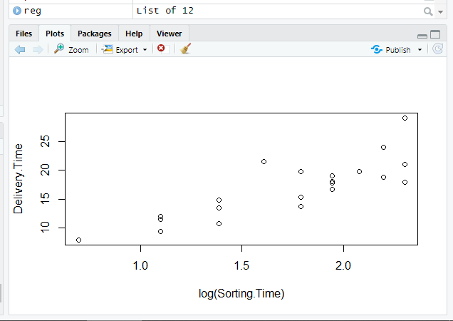

> cor(log(Sorting.Time),Delivery.Time)

[1] 0.8339325

> reg_log<-lm(Delivery.Time~log(Sorting.Time))

> summary(reg_log)

Call:

lm(formula = Delivery.Time ~ log(Sorting.Time))

Residuals:

Min 1Q Median 3Q Max

-4.0829 -2.0133 -0.1965 0.9351 7.0171

Coefficients:

Estimate Std. Error

(Intercept) 1.160 2.455

log(Sorting.Time) 9.043 1.373

t value Pr(>|t|)

(Intercept) 0.472 0.642

log(Sorting.Time) 6.587 2.64e-06 ***

---

Signif. codes:

0 ‘***’ 0.001 ‘**’ 0.01 ‘*’ 0.05

‘.’ 0.1 ‘ ’ 1

Residual standard error: 2.873 on 19 degrees of freedom

Multiple R-squared: 0.6954, Adjusted R-squared: 0.6794

F-statistic: 43.39 on 1 and 19 DF, p-value: 2.642e-06

> predict(reg_log)

1 2 3 4

21.98291 13.69652 17.36331 21.03009

5 6 7 8

21.98291 17.36331 18.75735 11.09489

9 10 11 12

21.98291 21.03009 19.96493 13.69652

13 14 15 16

18.75735 11.09489 11.09489 13.69652

17 18 19 20

17.36331 18.75735 7.42810 18.75735

21

15.71450

> reg_log$residuals

1 2 3

-0.9829125 -0.1965166 2.3866948

4 5 6

2.9699062 7.0170875 -2.0133052

7 8 9

0.2426465 -1.5948887 -4.0829125

10 11 12

-2.2800938 -0.1349331 -2.9465166

13 14 15

-2.0773535 0.4051113 0.9351113

16 17 18

1.1834834 -3.6133052 -0.6473535

19 20 21

0.5718999 -0.9273535 5.7855040

> confint(reg_log,level = 0.95)

2.5 % 97.5 %

(Intercept) -3.97778 6.297147

log(Sorting.Time) 6.16977 11.917057

> predict(reg_log,interval = "predict")

fit lwr upr

1 21.98291 15.6099875 28.35584

2 13.69652 7.4628028 19.93023

3 17.36331 11.2049447 23.52167

4 21.03009 14.7287585 27.33143

5 21.98291 15.6099875 28.35584

6 17.36331 11.2049447 23.52167

7 18.75735 12.5700473 24.94466

8 11.09489 4.6786298 17.51115

9 21.98291 15.6099875 28.35584

10 21.03009 14.7287585 27.33143

11 19.96493 13.7271824 26.20268

12 13.69652 7.4628028 19.93023

13 18.75735 12.5700473 24.94466

14 11.09489 4.6786298 17.51115

15 11.09489 4.6786298 17.51115

16 13.69652 7.4628028 19.93023

17 17.36331 11.2049447 23.52167

18 18.75735 12.5700473 24.94466

19 7.42810 0.5911537 14.26505

20 18.75735 12.5700473 24.94466

21 15.71450 9.5493253 21.87967

Warning message:

In predict.lm(reg_log, interval = "predict") :

predictions on current data refer to _future_ responses

> plot(Sorting.Time,log(Delivery.Time))

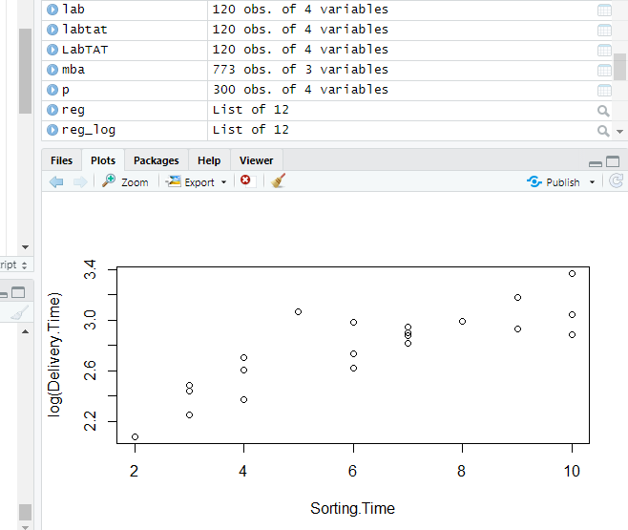

> cor(Sorting.Time,log(Delivery.Time))

[1] 0.8431773

> reg_exp<-lm(log(Delivery.Time)~Sorting.Time)

> summary(reg_exp)

Call:

lm(formula = log(Delivery.Time) ~ Sorting.Time)

Residuals:

Min 1Q Median 3Q Max

-0.29209 -0.13364 0.02065 0.08421 0.41892

Coefficients:

Estimate Std. Error t value Pr(>|t|)

(Intercept) 2.12137 0.10297 20.601 1.86e-14 ***

Sorting.Time 0.10555 0.01544 6.836 1.59e-06 ***

---

Signif. codes: 0 ‘***’ 0.001 ‘**’ 0.01 ‘*’ 0.05 ‘.’ 0.1 ‘ ’ 1

Residual standard error: 0.1755 on 19 degrees of freedom

Multiple R-squared: 0.7109, Adjusted R-squared: 0.6957

F-statistic: 46.73 on 1 and 19 DF, p-value: 1.593e-06

> predict(reg_exp)

1 2 3 4 5 6 7 8 9

3.176888 2.543578 2.754681 3.071336 3.176888 2.754681 2.860233 2.438027 3.176888

10 11 12 13 14 15 16 17 18

3.071336 2.965785 2.543578 2.860233 2.438027 2.438027 2.543578 2.754681 2.860233

19 20 21

2.332475 2.860233 2.649130

> reg_exp$residuals

1 2 3 4 5 6

-0.132365397 0.059111439 0.228472049 0.106717594 0.190407996 -0.023565969

7 8 9 10 11 12

0.084205939 -0.186734850 -0.292087121 -0.140142484 0.021411304 -0.168672492

13 14 15 16 17 18

-0.046022644 0.004320387 0.049376881 0.156439783 -0.133642618 0.036231231

19 20 21

-0.253033509 0.020649391 0.418923091

> confint(reg_exp,level=0.95)

2.5 % 97.5 %

(Intercept) 1.90584807 2.3368956

Sorting.Time 0.07323457 0.1378686

> predict(reg_exp,interval = "predict")

fit lwr upr

1 3.176888 2.781212 3.572563

2 2.543578 2.160938 2.926219

3 2.754681 2.378596 3.130767

4 3.071336 2.684495 3.458178

5 3.176888 2.781212 3.572563

6 2.754681 2.378596 3.130767

7 2.860233 2.483289 3.237177

8 2.438027 2.048112 2.827941

9 3.176888 2.781212 3.572563

10 3.071336 2.684495 3.458178

11 2.965785 2.585230 3.346340

12 2.543578 2.160938 2.926219

13 2.860233 2.483289 3.237177

14 2.438027 2.048112 2.827941

15 2.438027 2.048112 2.827941

16 2.543578 2.160938 2.926219

17 2.754681 2.378596 3.130767

18 2.860233 2.483289 3.237177

19 2.332475 1.932798 2.732152

20 2.860233 2.483289 3.237177

21 2.649130 2.271132 3.027128

Warning message:

In predict.lm(reg_exp, interval = "predict") :

predictions on current data refer to _future_ responses

> plot(Sorting.Time*Sorting.Time,Delivery.Time)

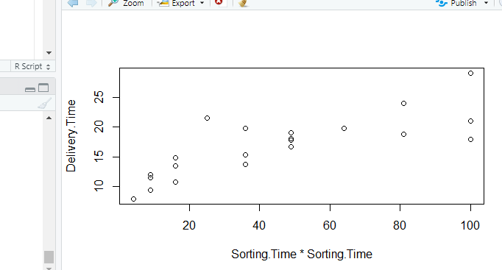

> cor(Sorting.Time*Sorting.Time,Delivery.Time)

[1] 0.7939063

> reg_poly <- lm(Delivery.Time~Sorting.Time+I(Sorting.Time^2))

> summary(reg_poly)

Call:

lm(formula = Delivery.Time ~ Sorting.Time + I(Sorting.Time^2))

Residuals:

Min 1Q Median 3Q Max

-4.4324 -1.6951 -0.5365 0.9075 6.6676

Coefficients:

Estimate Std. Error t value Pr(>|t|)

(Intercept) 3.5222 4.1597 0.847 0.4082

Sorting.Time 2.8130 1.4608 1.926 0.0701 .

I(Sorting.Time^2) -0.0932 0.1151 -0.810 0.4286

---

Signif. codes: 0 ‘***’ 0.001 ‘**’ 0.01 ‘*’ 0.05 ‘.’ 0.1 ‘ ’ 1

Residual standard error: 2.962 on 18 degrees of freedom

Multiple R-squared: 0.6934, Adjusted R-squared: 0.6594

F-statistic: 20.36 on 2 and 18 DF, p-value: 2.391e-05

> predict(reg_poly)

1 2 3 4 5 6 7 8

22.332430 13.283069 17.045108 21.290194 22.332430 17.045108 18.646533 11.122455

9 10 11 12 13 14 15 16

22.332430 21.290194 20.061562 13.283069 18.646533 11.122455 11.122455 13.283069

17 18 19 20 21

17.045108 18.646533 8.775444 18.646533 15.257287

> reg_poly$residuals

1 2 3 4 5 6 7

-1.3324296 0.2169308 2.7048917 2.7098061 6.6675704 -1.6951083 0.3534667

8 9 10 11 12 13 14

-1.6224550 -4.4324296 -2.5401939 -0.2315618 -2.5330692 -1.9665333 0.3775450

15 16 17 18 19 20 21

0.9075450 1.5969308 -3.2951083 -0.5365333 -0.7754444 -0.8165333 6.2427130

> confint(reg_poly, level = 0.95)

2.5 % 97.5 %

(Intercept) -5.2169258 12.2613936

Sorting.Time -0.2560669 5.8820703

I(Sorting.Time^2) -0.3349939 0.1485975

> predict(reg_poly, interval = "predict")

fit lwr upr

1 22.332430 15.360768 29.30409

2 13.283069 6.796484 19.76965

3 17.045108 10.506802 23.58341

4 21.290194 14.728917 27.85147

5 22.332430 15.360768 29.30409

6 17.045108 10.506802 23.58341

7 18.646533 12.120732 25.17233

8 11.122455 4.434281 17.81063

9 22.332430 15.360768 29.30409

10 21.290194 14.728917 27.85147

11 20.061562 13.573170 26.54995

12 13.283069 6.796484 19.76965

13 18.646533 12.120732 25.17233

14 11.122455 4.434281 17.81063

15 11.122455 4.434281 17.81063

16 13.283069 6.796484 19.76965

17 17.045108 10.506802 23.58341

18 18.646533 12.120732 25.17233

19 8.775444 1.423580 16.12731

20 18.646533 12.120732 25.17233

21 15.257287 8.758744 21.75583

Warning message:

In predict.lm(reg_poly, interval = "predict") :

predictions on current data refer to _future_ responses

> plot((Sorting.Time^3), Delivery.Time)

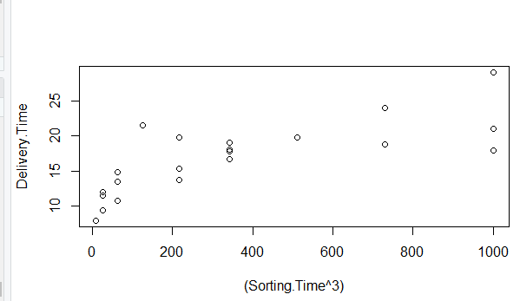

> cor(Sorting.Time^3,Delivery.Time)

[1] 0.7540763

> reg_poly3 <- lm(Delivery.Time~Sorting.Time+I(Sorting.Time^2)+I(Sorting.Time^3))

> summary(reg_poly3)

Call:

lm(formula = Delivery.Time ~ Sorting.Time + I(Sorting.Time^2) +

I(Sorting.Time^3))

Residuals:

Min 1Q Median 3Q Max

-4.8972 -1.7972 -0.1601 0.8077 6.2028

Coefficients:

Estimate Std. Error t value Pr(>|t|)

(Intercept) -4.15818 10.98653 -0.378 0.710

Sorting.Time 7.50248 6.37003 1.178 0.255

I(Sorting.Time^2) -0.92525 1.10553 -0.837 0.414

I(Sorting.Time^3) 0.04446 0.05874 0.757 0.460

Residual standard error: 2.998 on 17 degrees of freedom

Multiple R-squared: 0.7034, Adjusted R-squared: 0.6511

F-statistic: 13.44 on 3 and 17 DF, p-value: 9.586e-05

> predict(reg_poly3)

1 2 3 4 5 6 7 8

22.797240 13.892856 17.150048 20.827000 22.797240 17.150048 18.270140 11.222284

9 10 11 12 13 14 15 16

22.797240 20.827000 19.406879 13.892856 18.270140 11.222284 11.222284 13.892856

17 18 19 20 21

17.150048 18.270140 7.501412 18.270140 15.779865

> reg_poly3$residuals

1 2 3 4 5 6 7

-1.7972404 -0.3928561 2.5999522 3.1730001 6.2027596 -1.8000478 0.7298599

8 9 10 11 12 13 14

-1.7222837 -4.8972404 -2.0769999 0.4231213 -3.1428561 -1.5901401 0.2777163

15 16 17 18 19 20 21

0.8077163 0.9871439 -3.4000478 -0.1601401 0.4985883 -0.4401401 5.7201347

> confint(reg_poly3,level = 0.95)

2.5 % 97.5 %

(Intercept) -27.33772564 19.0213717

Sorting.Time -5.93710786 20.9420660

I(Sorting.Time^2) -3.25771246 1.4072034

I(Sorting.Time^3) -0.07947156 0.1683837

> predict(reg_poly3,interval = "predict")

fit lwr upr

1 22.797240 15.5939839 30.00050

2 13.892856 7.0844910 20.70122

3 17.150048 10.4982995 23.80180

4 20.827000 14.0344853 27.61951

5 22.797240 15.5939839 30.00050

6 17.150048 10.4982995 23.80180

7 18.270140 11.5550572 24.98522

8 11.222284 4.4189573 18.02561

9 22.797240 15.5939839 30.00050

10 20.827000 14.0344853 27.61951

11 19.406879 12.5644227 26.24933

12 13.892856 7.0844910 20.70122

13 18.270140 11.5550572 24.98522

14 11.222284 4.4189573 18.02561

15 11.222284 4.4189573 18.02561

16 13.892856 7.0844910 20.70122

17 17.150048 10.4982995 23.80180

18 18.270140 11.5550572 24.98522

19 7.501412 -0.7718603 15.77468

20 18.270140 11.5550572 24.98522

21 15.779865 9.0162244 22.54351

Warning message:

In predict.lm(reg_poly3, interval = "predict") :

predictions on current data refer to _future_ responses

> plot(reg_exp)

Hit <Return> to see next plot: plot(reg_exp)

Hit <Return> to see next plot: plot(reg_exp)

Hit <Return> to see next plot: plot(reg_exp)

Hit <Return> to see next plot: plot(reg_exp)

>

> plot(reg_exp)

Hit <Return> to see next plot: plot(reg_exp)

Hit <Return> to see next plot: plot(reg_exp)

Hit <Return> to see next plot: plot(reg_exp)

Hit <Return> to see next plot: plot(reg_exp)

> plot(reg_exp)

Hit <Return> to see next plot: plot(reg_exp)

Hit <Return> to see next plot: plot(reg_exp)

Hit <Return> to see next plot: plot(reg_exp)

Hit <Return> to see next plot: plot(reg_exp)

> plot(reg_exp)

